**Faculty of Information Technology**

**Automated Camera Stand**

Group 47

**P.A.U.D. Herath 204074M**

P.H.P. Jayathilaka 204087F

D.M.B.M. Dissanayake 204047J

S.P.S.N. Pathirana 204150T

A.M.D.B. Rathnayaka 204179N

Ms. Chanduni Gamage

Lecturer

Dept. of Information Technology

…………………………….

Supervisor’s Name: Mr. B.H. Sudantha

Dean/Senior Lecturer

Faculty of Information Technology

Signature of Supervisor: …………………………….

Date of Submission: 24/09/2021

### 

### Table of Content

Table of Content i

Table of Figures ii

Introduction 1

Literature Survey 2

Aim & Objectives 3

Analysis and Design 4

Testing and Implementation 7

Previous Action Plan 11

Action Plan for Remaining Work 11

References 12

APPENDIX A - Cost Estimation and Expenditure so far 13

APPENDIX B - Individual Contribution to the Project 14

### Table of Figures

Figure 1 Beetle cam 2

Figure 2 Block Diagram of Proposed System 4

Figure 3 System Diagram of Proposed System 4

Figure 4 Back lower 3D view 5

Figure 5 Remote controller 3D view 5

Figure 6 Back upper 3D view 5

Figure 7 Front lower 3D view 5

Figure 8 Named Camera Stand 3D view 6

Figure 9 Atmega32 Pin Configuration 7

Figure 10 Atmega32 Physical view 7

Figure 11 Read ADC value code sample 7

Figure 12 Thumb Joystick 7

Figure 13 LCD Display Physical view 8

Figure 14 Code for LCD Display 8

Figure 15 Servo motor Physical view 9

Figure 16 Servo motors proteus schematic view 9

Figure 17 L298N IC Config for motors 9

Figure 18 4x4 Keypad and RF receiver Proteus view 10

Figure 19 Digital input and output code 10

Figure 20 Remote controller circuit Proteus schematic view 10

Figure 21 GPS Module NEO-6M 14

Figure 22 USART sample code 14

Figure 23 GPS Module Proteus Schematic view 14

Figure 24 Ultrasonic sensor Physical view 15

Figure 25 Ultrasonic sensor Code 15

Figure 26 Motor Controlling code 15

Figure 27 High torque gear motor Physical view 15

Figure 28 Thumb Joystick Physical view 16

Figure 29 ADC configuration and read 16

Figure 30 Use variable resister for Joystick 16

Figure 31 Servo motor physical view 17

Figure 33 Servo motor sample code 17

Figure 32 Servo motor Proteus schematic view 17

Figure 34 Siren Proteus schematic view 17

Figure 35 Siren Physical view 17

Figure 36 RF Receiver Physical view 18

Figure 37 ADC initializing code 18

### Introduction

Wildlife photography is a popular category of photography, done by beginners, enthusiasts, and professionals. When taken technically, it involves capturing any type of animal, from birds to insects to butterflies to mammals. But wildlife photographers most commonly take photos of mammals, reptiles, amphibians, and birds. Wildlife photography is a loosely defined profession that demands a passion for nature and art. These photographers make a career of traveling to remote areas and taking pictures of wild animals and natural scenery with a risk.[01]

Wildlife photographers are some of the world’s most valued professionals. According to the U.S. Bureau of Labor Statistics, the average annual wage of most wildlife photographers was $50,290 per year, or $24.18 per hour, as of May 2020. So, this is a higher-paying job. Due to this reason, many new photographers have come to this field. And most wildlife photographers are freelancers. The amount of money that a freelance wildlife photographer makes is largely determined by his talent and ability to get decent-paying work. From all these things it is crystal clear that wildlife photography is one of the best careers in the world.

Wildlife photography is one of the most dangerous professions in the world. The following instances are examples of the dangerous which happen for wildlife photographers. One such incident happened in May of 2000 when a female wildlife photographer was attacked and partially eaten by a 112-pound female black bear in Tennessee. Last year in Colorado a wildlife biologist and photographer, Tom Mussel, got too close to a cow elk and her calf, and he was attacked when he stumbled as he tried to escape the charging cow. Elk and deer will attack humans when they feel cornered or threatened. A southern California man killed by a grizzly bear in Alaska's backcountry was shooting photos of the animal that killed him just moments before the attack, a National Park Service official said Sunday. The bear that killed Richard White, 49, was still with his body when rangers found him in Danail National Park, the official said. Photographs found in his camera revealed that White was watching the bear for at least eight minutes near a river before the attack [02].

From our project, we mainly focused on avoiding the danger for the wildlife photographer and the safety of the camera. In this period many wildlife photographers are dying while taking photos due to animal attacks. We are going to introduce a new device to avoid such a problem. It is an Automated Camera Stand.

### Literature Survey

In modern cameras, we have the feature to take remote photos. We call it remote photography. Therefore, we can take pictures even if we are far from the camera. But there is no way to bring the camera near to the animals rather than a person carrying the camera.

From the photographer’s side:

* + Danger to the life of the photographer.
  + Time wastage of the photographer.
  + Can’t find a good angle to take a photo.
  + Can’t get close enough to the animal.
  + Constantly changing lighting conditions.
  + No safety to the camera.

From the animal’s side:

* + Animals get scared when we try to reach them.
  + The behaviors of the animals may change.

From the environment side:

* + Bad impact on biodiversity.

Therefore, when we try to find out a solution for this we came across with some similar projects.

#### A close-up of a binoculars Description automatically generated with low confidenceBeetle cam for wildlife photography

Beetle cam has designed to take wildlife photographs. Wildlife photographer Will Burrard-Lucas had long wanted to add up-close-and-personal images of iconic African animals to his portfolio. But to get those intimate shot of lions and leopards, he would need to crawl up right next to their sharp-toothed faces [03]. This beetle cam can move forward and backward by using the remote controller. And also, beetle cam can be turned by using the wheels.

Figure 1 Beetle cam

In our product we have all the functionalities same as the beetle cam. But there are some uncommon functionalities rather than this beetle cam. There is a special feature that can move the camera to the location easily by using GPS location guiding and can avoid obstacles itself. And also, can rotate the camera vertically using the remote controller. There is a siren for the safety of the camera.

### Aim & Objectives

#### Aim

This project aims to the distance photography process to make sure it is safer and effective.

#### Objectives

The objectives of the project are as follows,

* Rotate the camera both vertically and horizontally.
* Move the stand according to the given GPS coordinates.
* Reach the target safely.
* Protect the camera from the animals by using the alarm.
* Control the camera holder using a remote controller.

### Analysis and Design

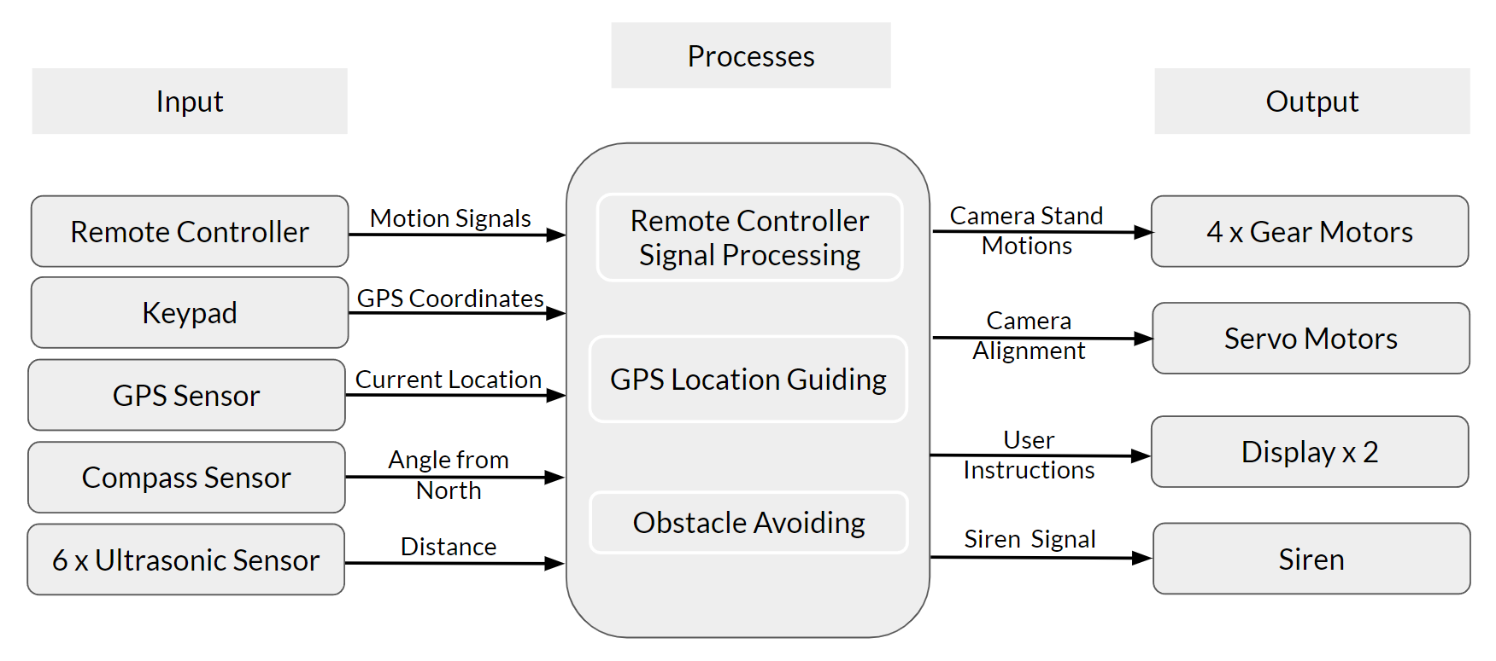

Figure 2 Block Diagram of Proposed System

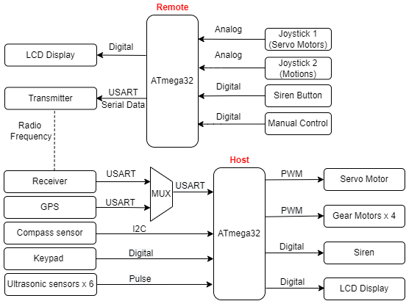

Figure 3 System Diagram of Proposed System

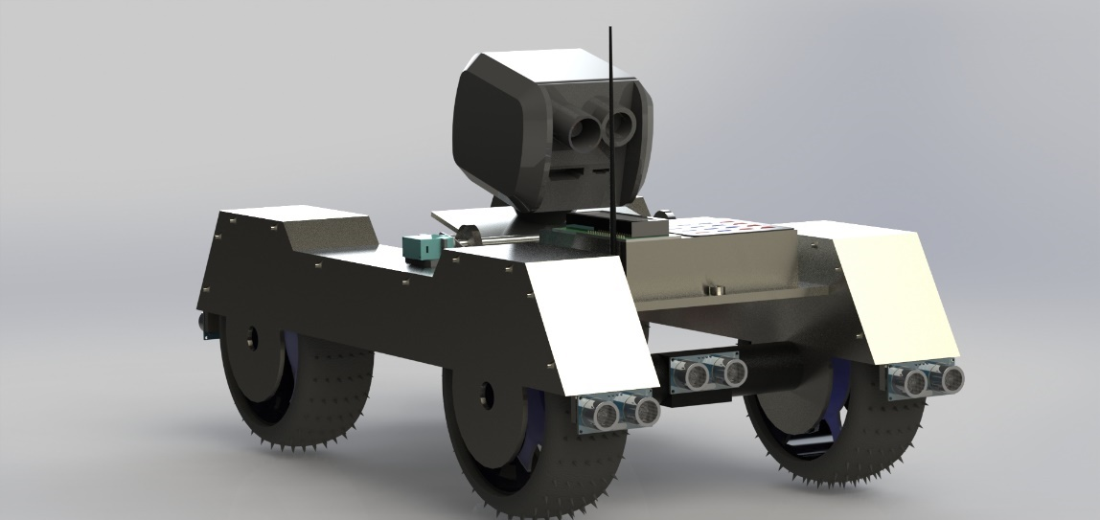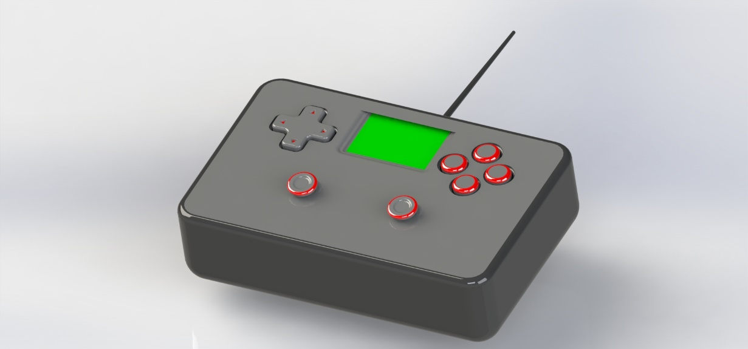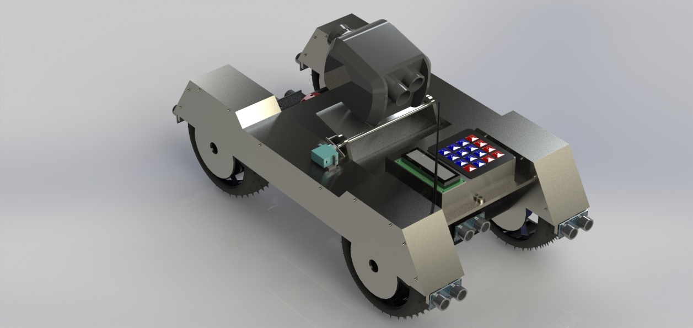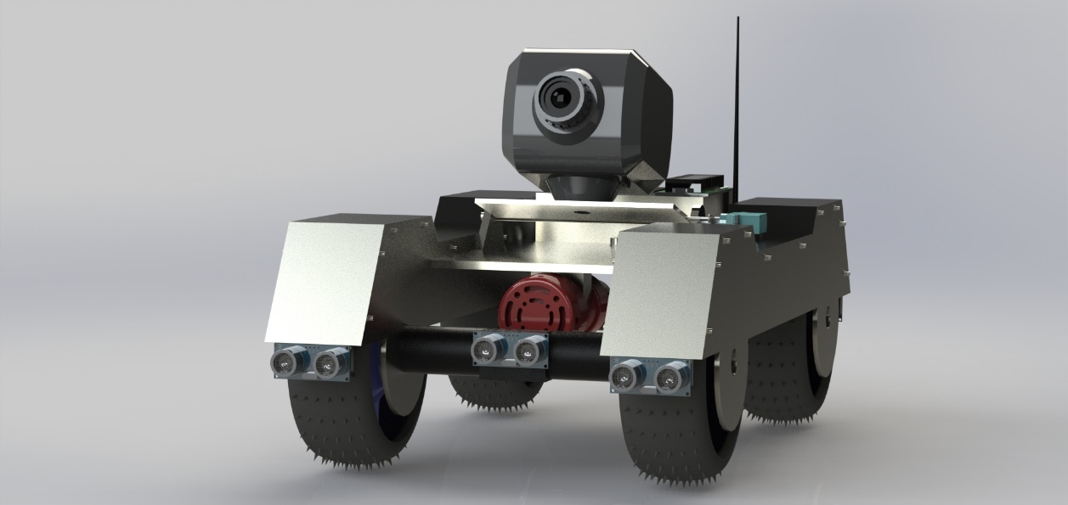

Figure 4 Back lower 3D view

Figure 5 Remote controller 3D view

Figure 6 Back upper 3D view

Figure 7 Front lower 3D view

Figure 8 Named Camera Stand 3D view

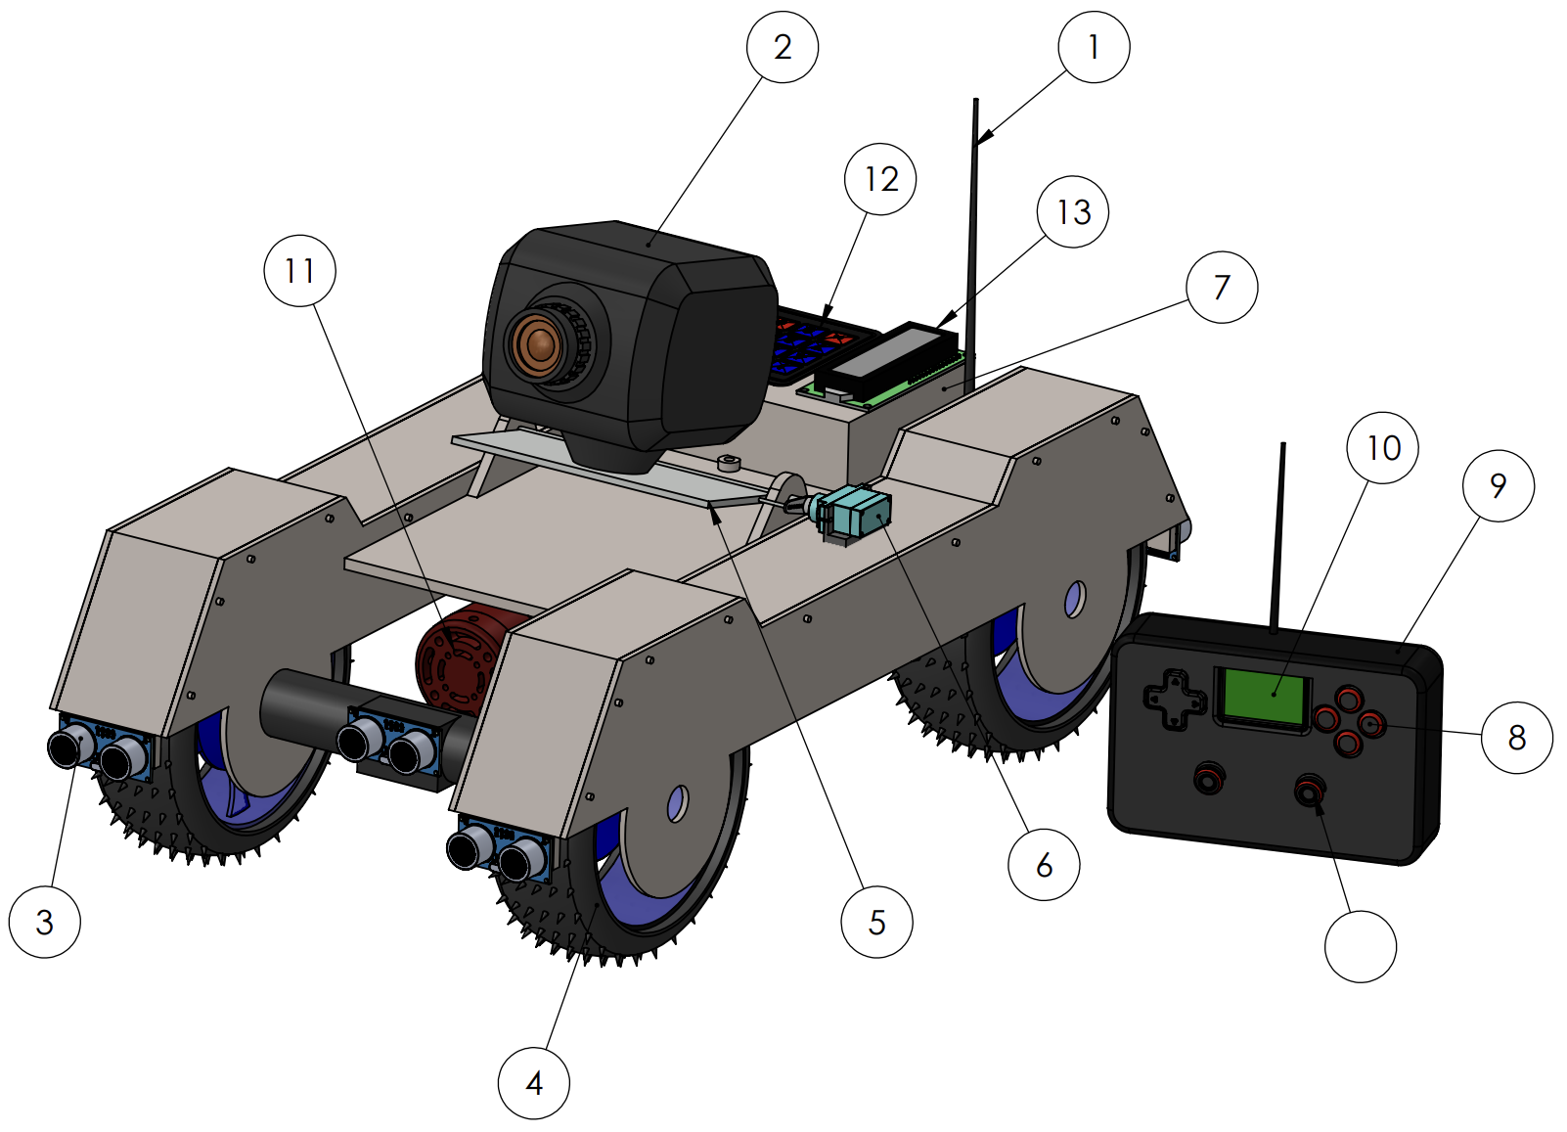

14

1. Remote controller buttons
2. Remote controller
3. LCD Display
4. Siren
5. 4x4 Numpad
6. LCD Display
7. Joystick
8. RF Antenna
9. Camera
10. Ultrasonic sensors
11. Wheels with gear motors
12. Universal camera mount
13. Servo motor
14. Project box
    1. Atmega32 IC
    2. GPS module
    3. Compass sensor
    4. RF receiver

### Testing and Implementation

In our project, there are two ATmega32 microcontrollers, one is for remote controller and the other one is for the host (Camera stand). The microcontroller takes inputs related to motions and angles from two joysticks. The microcontroller of the remote processes the data and transmit from remote to host through RF (Radio Frequency) modules.

Then the microcontroller of the host gets data from the RF receiver module and GPS module using a 2×1 multiplexer. And also, the microcontroller of the host takes inputs from ultrasonic sensors, compass sensor and the keypad. The microcontroller of the host processes that data and send data to the servo motors and gear motors. And also send digital signals to the display and the siren.

Figure 9 Atmega32 Pin Configuration

#### A picture containing text, electronics Description automatically generatedATmega32 Microcontroller

Figure 10 Atmega32 Physical view

#### Text Description automatically generatedThumb Joystick

Figure 11 Read ADC value code sample

These joystick modules are used to control movements of the camera stand and the vertical camera angle.

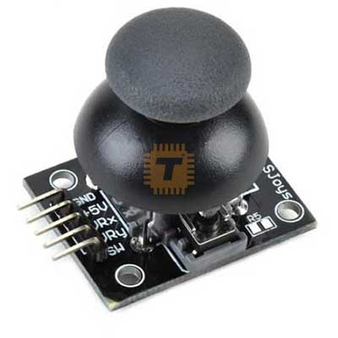

Figure 12 Thumb Joystick

#### I2C Liquid Crystal Display (LCD) 16x2 - Maker AdvisorLiquid Crystal 16 × 2 Display

Figure 13 LCD Display Physical view

These LCD displays are used to show GPS coordinates and the current remote’s configurations. By using this we can convert camera stand more user friendly.

Figure 14 Code for LCD Display

#### Servo motor

Figure 15 Servo motor Physical view

This servo motor is used to change the vertical angle of the camera.

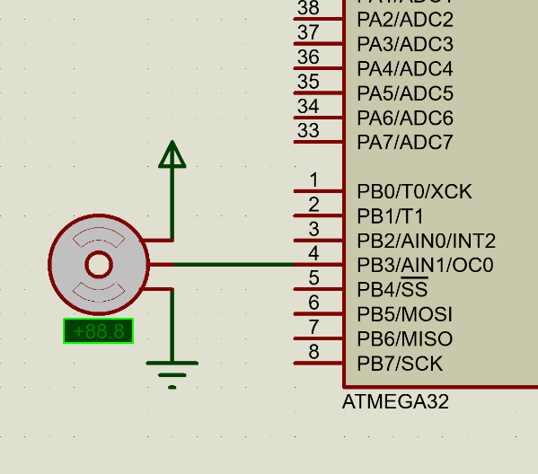

Figure 16 Servo motors proteus schematic view

#### Moter drive

Motor drive is used to amplify the PWM signal from the Atmega32 and supply it to the gear motors.

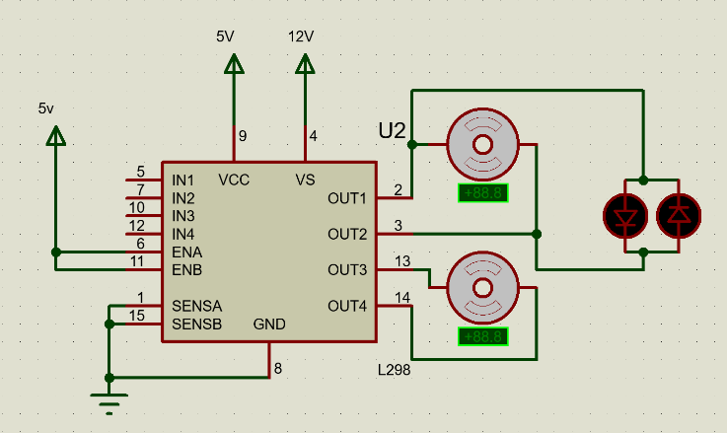

Figure 17 L298N IC Config for motors

Screen shots of the project.

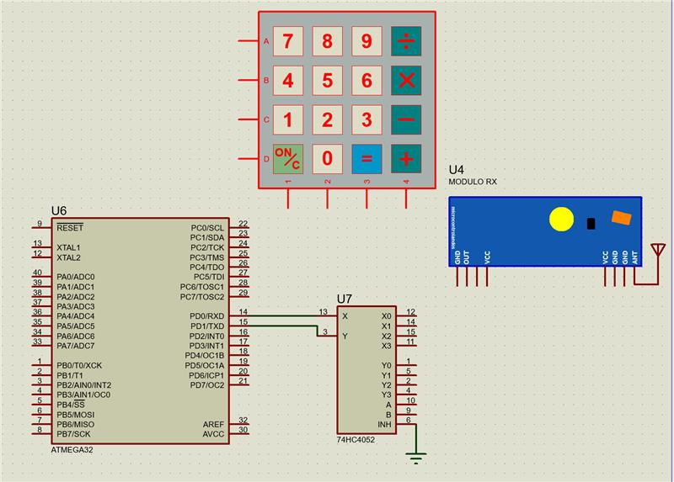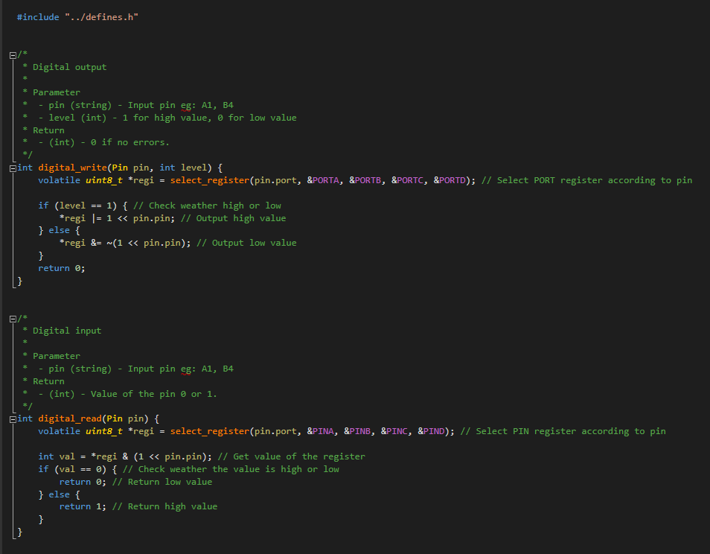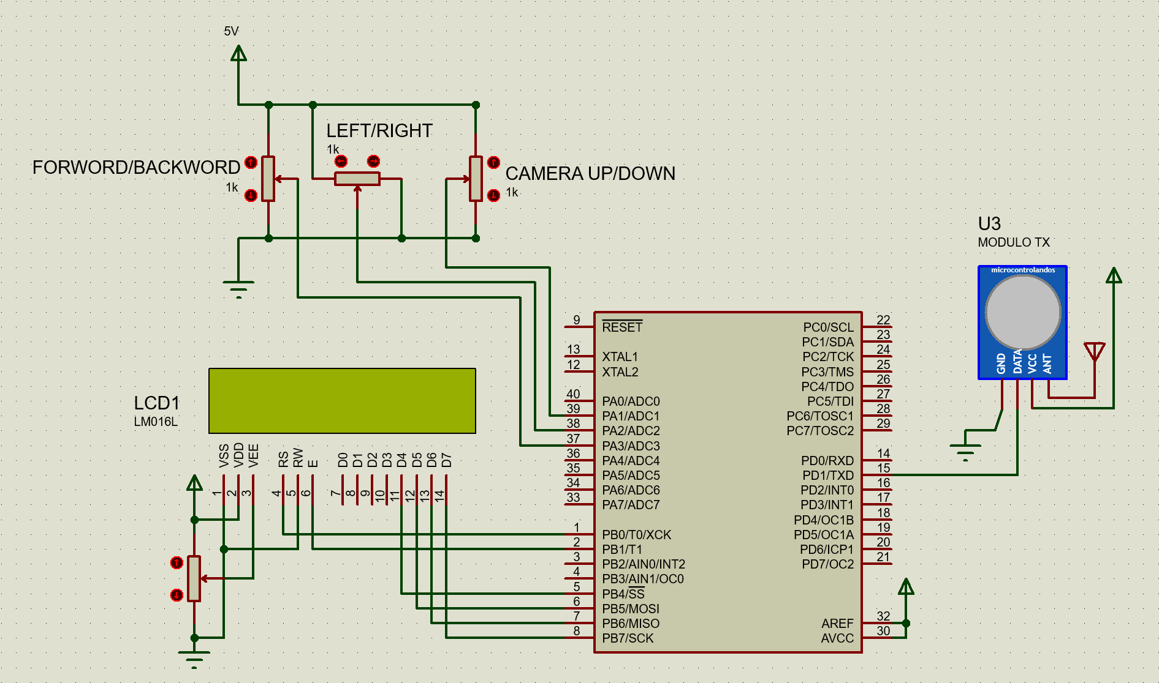

Figure 18 4x4 Keypad and RF receiver Proteus view

Figure 19 Digital input and output code

Figure 20 Remote controller circuit Proteus schematic view

### Previous Action Plan



### Action Plan for Remaining Work



### References

|  |  |
| --- | --- |
| [1] | A. Duke, “Hiker photographs bear just before fatal grizzly attack,” *CNN*, 26-Aug-2012. |

|  |  |
| --- | --- |
| [2] | J. Dempsey, “Introduction to wildlife photography: A guide for beginners,” *Phototraces.com*, 03-Jan-2020. [Online]. Available: https://www.phototraces.com/b/wildlife-photography/. [Accessed: 28-Nov-2021]. |

|  |  |
| --- | --- |
| [3] | M. Gallucci, “These robots are transforming how we see wildlife,” *Mashable*, 12-Jan-2017. [Online]. Available: https://mashable.com/article/robots-wildlife-photography. [Accessed: 28-Nov-2021]. |

|  |  |
| --- | --- |
| [4] | “Microchip.lk – one stop for all your electronics…,” *Microchip.lk*. [Online]. Available: https://microchip.lk/. [Accessed: 28-Nov-2021]. |
| [5] | “TRONIC.LK,” *Lankatronics.com*. [Online]. Available: https://lankatronics.com/. [Accessed: 28-Nov-2021]. |

### APPENDIX A

### Cost Estimation and Expenditure so far



[4],[5]

### APPENDIX B

### Individual Contribution to the Project

#### P.A.U.D. Herath - 204074M

* Studied about the GPS module.
* Studied about the way how the GPS signals generate and the way of GPS working.
* Learnt about the theory regarding the USART communication.
* Understood the theory behind the multiplexer.

##### GPS module (NEO-6M)

The GPS module has a GPS antenna, battery, an EEPROM and a position fix LED indicator. The pins in the NEO-6M are Vcc, Tx, Rx and GND. Understood that the D0 and D1 pins must be used to take the serial data using the GPS module.

Specifications are,

* Operating Voltage: 2.7V - 3.6V
* Serial Baud Rate: 4800-230400(default 9600)
* Operating Current: 45mA

##### Multiplexer

When taking the inputs related to the GPS module and the receiver, I have to use the same pins (D0, D1). Therefore, I used a multiplexer to carry this out.

Figure 21 GPS Module NEO-6M

##### USART communication

To take the serial inputs from the GPS module, I used the USART method.

Figure 22 USART sample code

Figure 23 GPS Module Proteus Schematic view

#### P.H.P. Jayathilaka 204087F

* Studied about Ultrasonic sensors
* Studied about Display, Keypad, ADC, PWM
* Started studying about USART
* 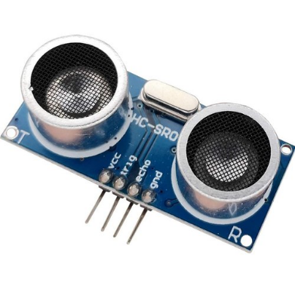Started to study interfacing components with the ATmega32 microcontroller and how to connect components to the microcontroller.

Figure 24 Ultrasonic sensor Physical view

##### Ultrasonic sensor (HC-SR04)

I am using 6 ultrasonic sensors to avoid obstacles. There are 4 pins in the ultrasonic sensor. (VCC, TrigPin, EchoPin, GND)

Specifications of Ultrasonic sensor:

Figure 25 Ultrasonic sensor Code

* Working Power: DC 5V; 15mA
* Working Frequency: 40Hz
* Accurate Range: 2cm – 40cm
* Measuring Angle: 15 degrees
* Trigger Input Signal: 10µS TTL pulse
* Echo Output Signal Input TTL lever signal and the range in proportion

##### Gear Motors

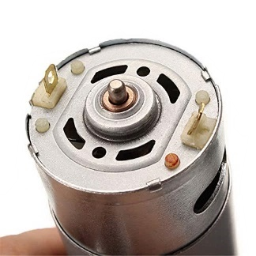Due to the lack of 8 PWM pins for four motors, I had to couple motors as left and right. Then needed PWM pins reduced to 4. furthermore, I used only 1 PWM pin and a digital pin per side. It is configured by code.

Figure 26 Motor Controlling code

Specifications of Gear motors:

* Working voltage: 12v DC
* Speed: 180RPM
* High torque motors
* 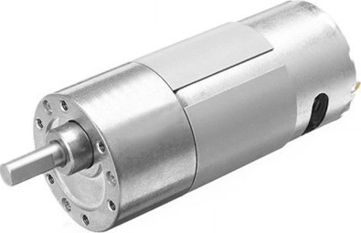Use L298N H-bridge motor drive

Figure 27 High torque gear motor Physical view

#### D.M.B.M. Dissanayake - 204047J

* Studied about Joystick and RF Transmitter
* Studied about ADC
* Started to study interfacing components with the ATmega32 microcontroller and how to connect components to the microcontroller.

In our project, I used a joystick to get inputs related to the angle of servo motors. The microcontroller of the remote gets analog inputs from this joystick. We need knowledge about ADC on AVR ATmega32 to process that analog signal. To get this analog input, I had to use A0 pin in the ATmega32 microcontroller. Furthermore, I used a 433 MHz RF transmitter to transmit the above-processed data from the microcontroller.

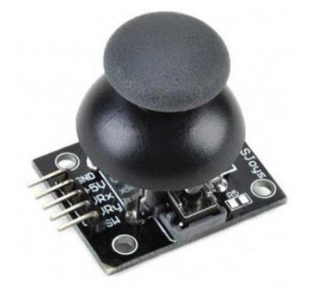

Figure 28 Thumb Joystick Physical view

##### Thumb Joystick

There are 5 pins in the joystick module.

VCC, GND, VRx, VRy, SW

Specifications:

* Operating Voltage: 5V
* Internal potentiometer value: 10kΩ
* Operating Temperature: 0 to 70 ֩C

There is no joystick module in proteus. Therefore, I used a variable resistor to connect with the microcontroller.

Figure 29 ADC configuration and read

Figure 30 Use variable resister for Joystick

#### S.P.S.N. Pathirana 204150T

* Studied about the Servo motors
* Studied about the Siren
* Started to learn about how they are working
* Started to learn about how they are interfacing with Atmega32 microcontroller

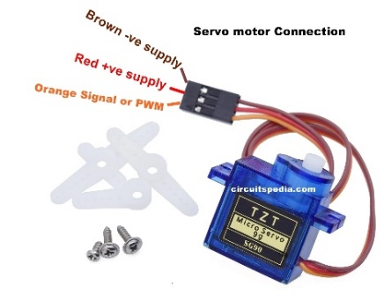In this project, Servo motor is used to change the angle of the camera, according to the signal of joystick.

Figure 31 Servo motor physical view

##### Servo Motor

* Speed: 0.1 s
* Text

  Description automatically generatedTorque: 2.5 kg/cm
* Weight: 14.7 g
* Voltage: 4.8v - 6v

Figure 32 Servo motor sample code

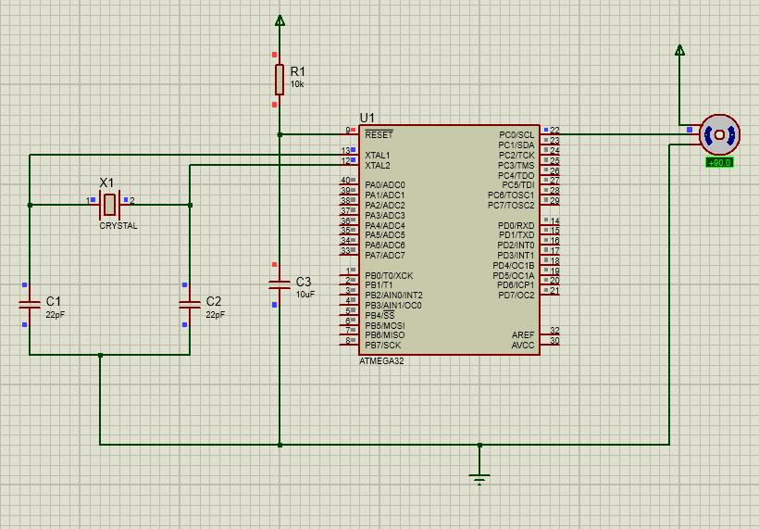

Figure 33 Servo motor Proteus schematic view

##### Siren

The siren is used for protecting the camera stand from the wild animals. When they come to attack it. The siren sounds according to the signal given by the siren button in the remote controller.

Figure 34 Siren Proteus schematic view

Figure 35 Siren Physical view

#### A.M.D.B. Rathnayaka 204179N

* Studied about the joystick
* Studied about the RF receiver
* Started to study about ADC
* Started to learn about how the components are working and interfacing with ATmega32 microcontroller

In our project, I have to give inputs to the ATmega32 microcontroller of the remote from joystick. Moreover, it gives inputs to the microcontroller of the host from the RF receiver.

##### 433 MHz Receiver

Figure 36 RF Receiver Physical view

Receiver uses the USART communication to communicate with the Atmega32 microcontroller of the host.

Specifications:

* Frequency: 433 MHz
* Operating voltage: 5V
* Supply current: 3.5 mA

##### Thumb Joystick

There are 5 pins in the joystick module. And the pins in this module are VCC, GND, VRx, VRy, SW.

Specifications:

* Operating Voltage: 5V
* Internal potentiometer value: 10kΩ
* Operating Temperature: 0 to 70 ֩C

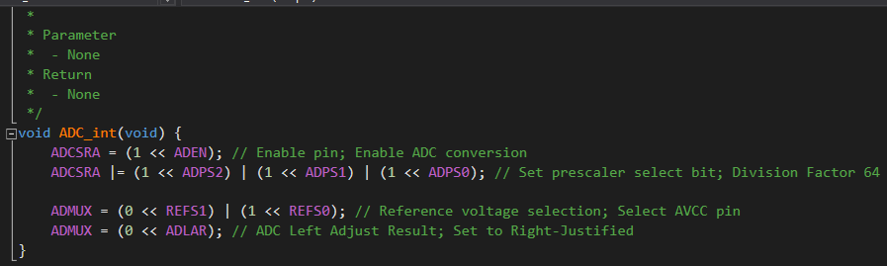

Figure 37 ADC initializing code